

Lab No. 7
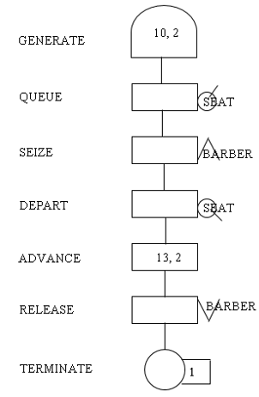
Create a GPSS model and program to simulate a barber shop for a day (9 a.m. to 4 p.m.), where a customer enters the shop every 10 ± 2 minutes and a barber takes 13 ± 2 minutes for a haircut.
Source Code:
GENERATE 10,2
QUEUE SEAT
SEIZE BARBER
DEPART SEAT
ADVANCE 13,2
RELEASE BARBER
TERMINATE 1
GENERATE 420
TERMINATE 1
START 1

Output:
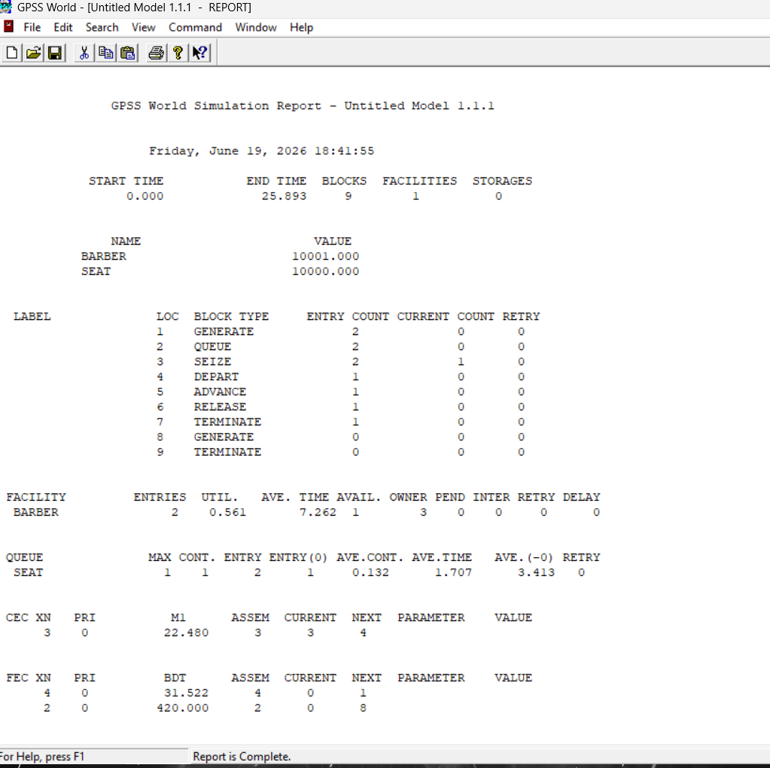


Lab No. 8
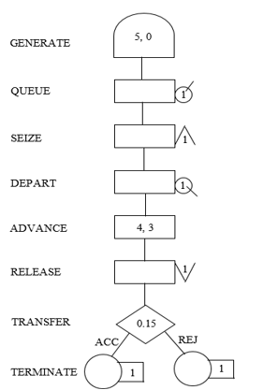
A machine tool in a manufacturing shop is turning out parts at the rate of every 5 minutes. When they are finished, the parts are sent to an inspector, who takes 4±3 minutes to examine each one and rejects 15% of the parts. Draw and explain a block diagram for it and write a GPSS program to simulate using the concept of FACILITY.
Source Code:
GENERATE 5,0
QUEUE INSQ
SEIZE INSPECTOR
DEPART INSQ
ADVANCE 4,3
RELEASE INSPECTOR
TRANSFER
0.15,REJ,ACC
ACC TERMINATE 1
REJ TERMINATE 1

Output:
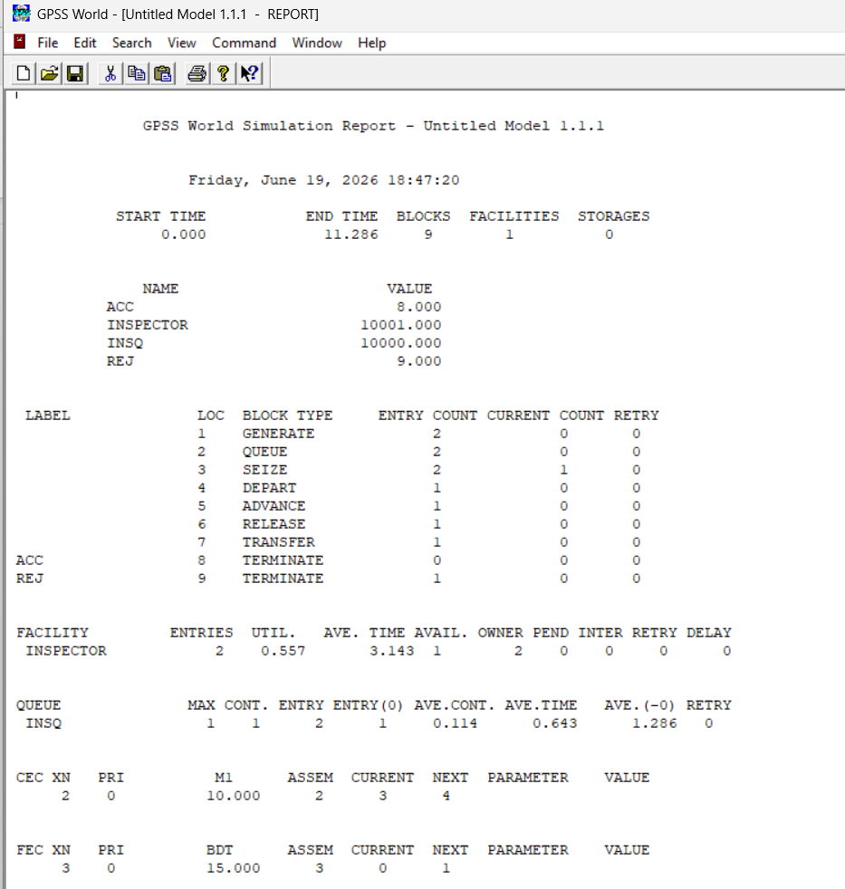



Lab No. 9
A GENERATE block is used to represent the output of the machine by creating one transaction every five units of time. A QUEUE block places the transaction in the queue and SEIZE block allows a transaction to engage a facility if it is available. If more than one inspector is available, the transaction leaves the queue which is denoted by DEPART block and enters into ADVANCE block. An ADVANCE block with a mean of 4 and modifier of 3 is used to represent inspection. The time spent on inspection will therefore be any one of the values 1, 2, 3, 4, 5, 6 or 7, with equal probability given to each value. Upon completion of the inspection, RELEASE block allows a transaction to disengage the facility and transaction go to a TRANSFER block with a selection factor of 0.15, so that 85% of the parts go to the next location called ACC, to represent accepted parts and 15% go to another location called REJ to represent rejects. Both locations reached from the TRANSFER block are TERMINATE blocks.

Source Code:
GENERATE 5,0,,,100
QUEUE INSQ
SEIZE INSPECTOR
DEPART INSQ
ADVANCE 4,3

RELEASE INSPECTOR
TRANSFER 0.15,REJ,ACC

ACC TERMINATE 1
REJ TERMINATE 1
START 100

Output:

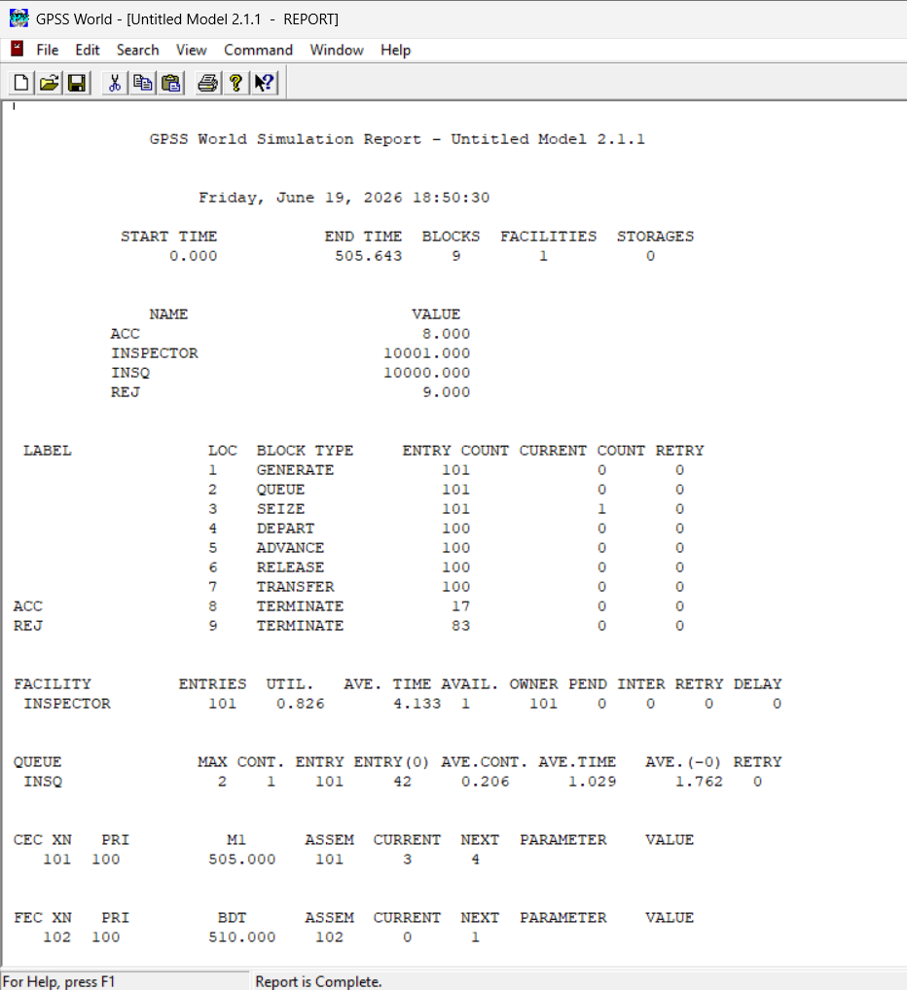



Lab No. 10
Parts are being made at the rate of one every 10 minutes. They are of two types; A and B. Mixed randomly with 10% being type B. Separate inspectors inspect each type. Inspection time for A is 6±2 minutes and for B is 10±2 minutes. Both inspectors reject 10% of parts. Simulate for 100 parts.
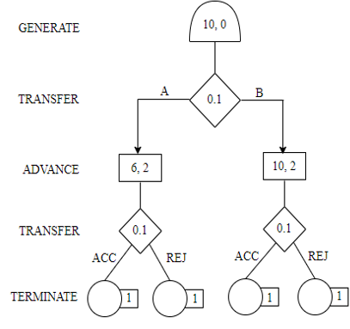
Source Code:
GENERATE 10,,,100
TRANSFER .10,TYPEB,TYPEA
TYPEA QUEUE AQUEUE
SEIZE INSPA
DEPART AQUEUE
ADVANCE 6,2
RELEASE INSPA
TRANSFER .10,REJA,ACCA

ACCA TERMINATE 1
REJA TERMINATE 1

TYPEB QUEUE BQUEUE
SEIZE INSPB
DEPART BQUEUE
ADVANCE 10,2
RELEASE INSPB
TRANSFER .10,REJB,ACCB

ACCB TERMINATE 1
REJB TERMINATE 1
START 100

Output:
